Disloc Tutorial

This tutorial walks through step-by-step how to generate a Disloc tilt map from QuakeSim in ArcMap. Please note that QuakeSim is planning to remodel their website Summer 2013. Information contained in this tutorial may be outdated.

1. Open the QuakeSim Portal (<http://quakesim.org/content/quakesim-portal>)
2. 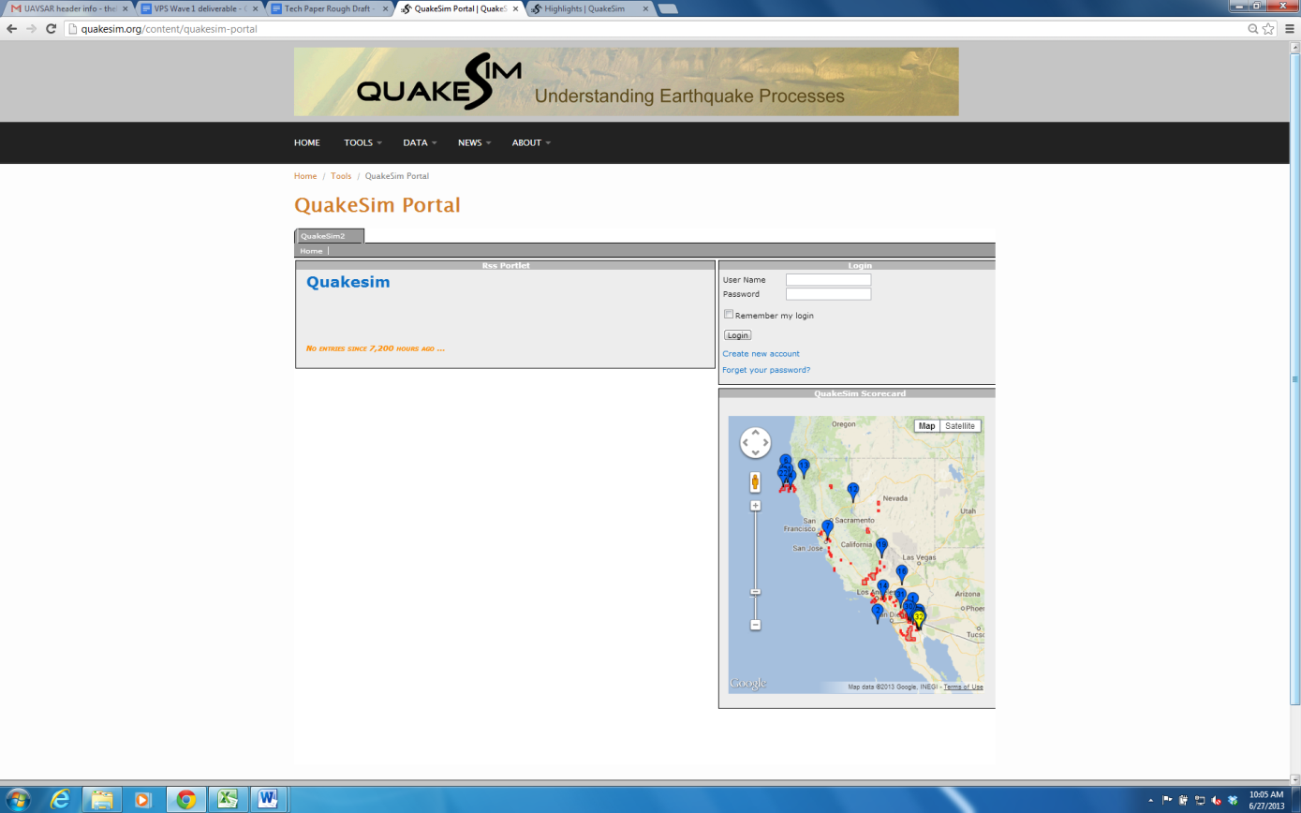 Log into the Portal. Create an account to save your projects.
3. 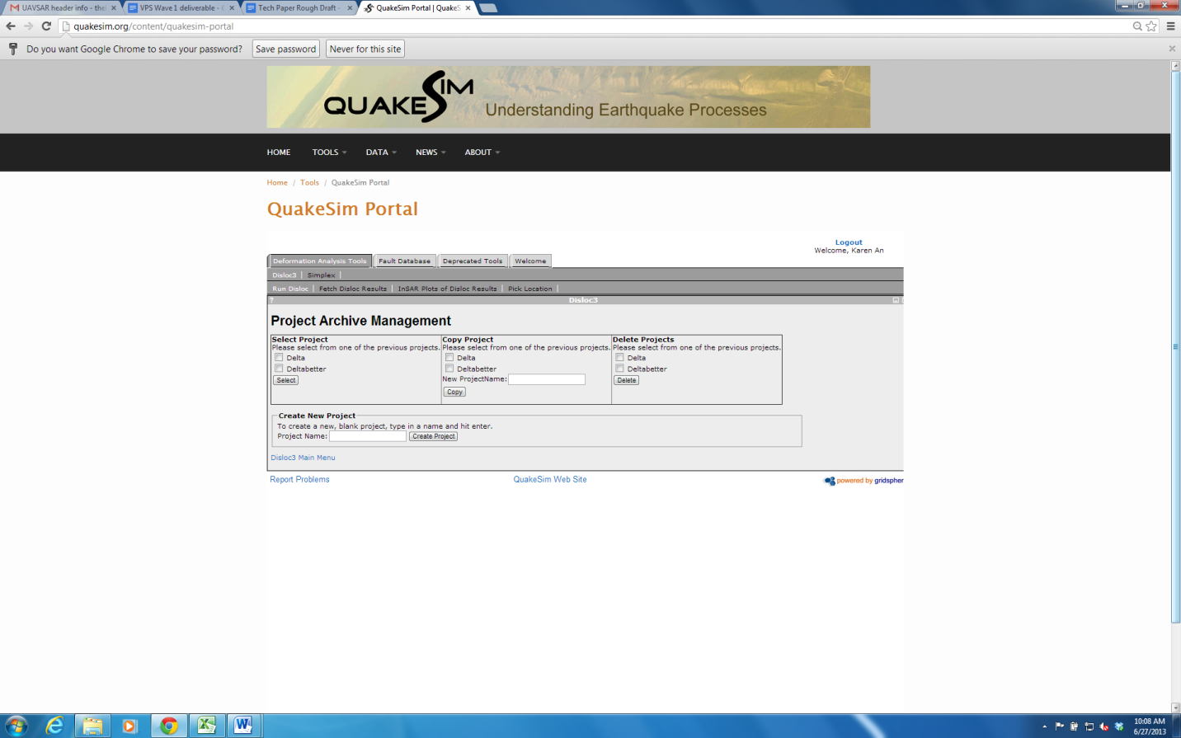To create a new project, enter the project name and click Create Project. You can also access and manage old projects in the Project Archive Management panel.
4. 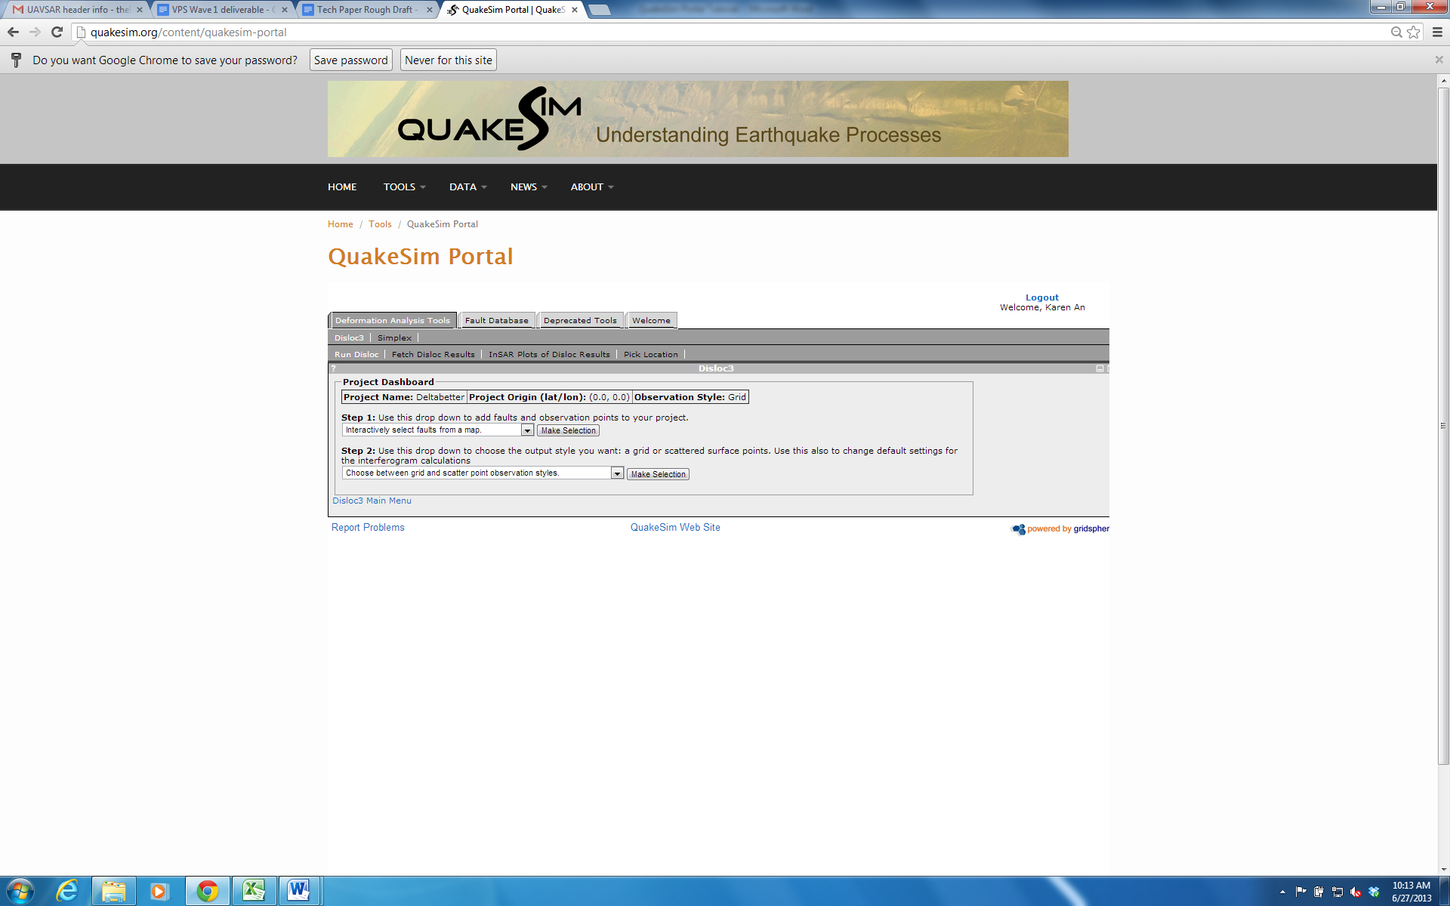For Step 1 in the Project Dashboard, click Make Selection with “Interactively select faults from a map” selected in the pull-down menu.
5. 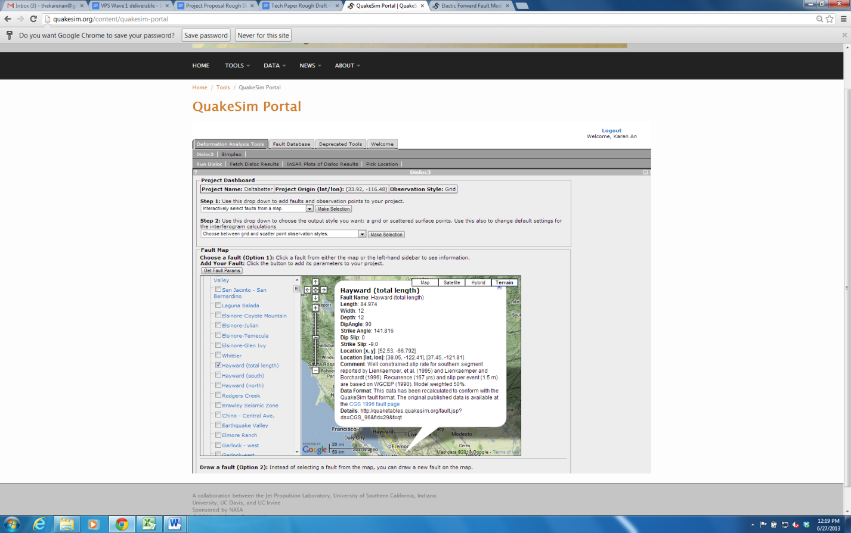The Fault Map will appear after this selection, with three folders of California fault lines. You may select fault(s) from the map itself or by expanding the folders on the left hand side. Checking a box will display the fault as a yellow line on the map. Clicking on the fault name or the yellow fault line selects the fault. Another option is expanding each folder and searching the page (Ctrl+F) if the name of the fault is known.

Once the fault(s) have been selected and the white pop-up box with the fault’s description is displayed, a Get Fault Params button should appear directly above the map.

1. Click the Get Fault Params button. The display should change to show Fault Components, in which you can edit a variety of variables. The main variable to edit is the Strike Slip value. Most of the major fault lines in California, including the San Andreas and Hayward, are strike slip faults. This value can be measured directly after an event or estimated for preventive efforts (slip values can range from a few centimeters to hundreds of kilometers). Click Update once all edits have been made.

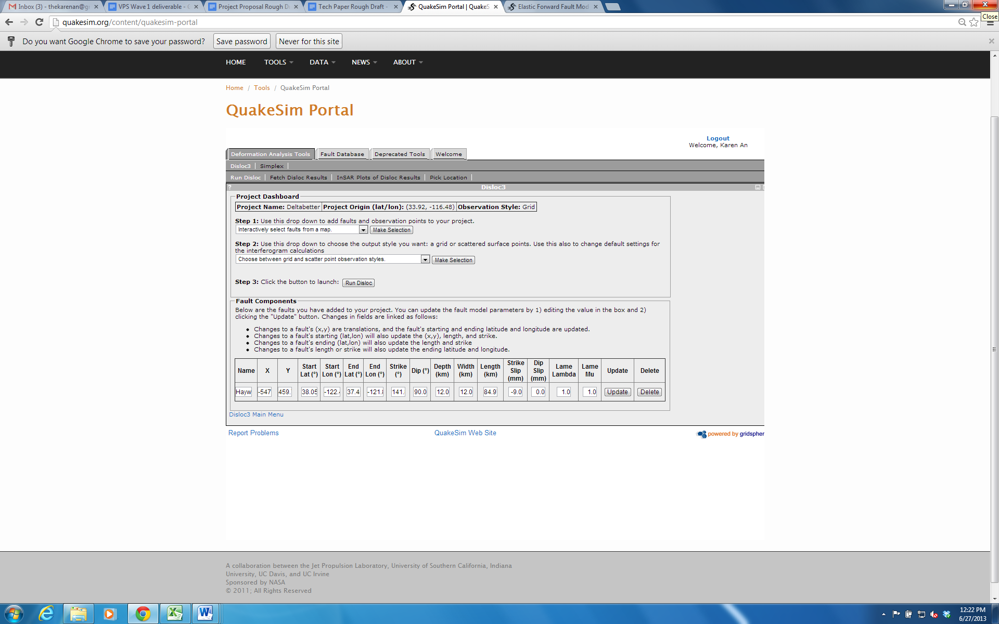

The strike slip value can be verified using QuakeSim’s Moment Magnitude Calculator. Navigate to it from Tools > Calculate MW in the upper menu bar.

1. For Step 2 in the Project Dashboard, select “Update your observation grid or scatter points and (re)set project origin” and click Make Selection. An Observation Components panel should appear beneath the Project Dashboard.

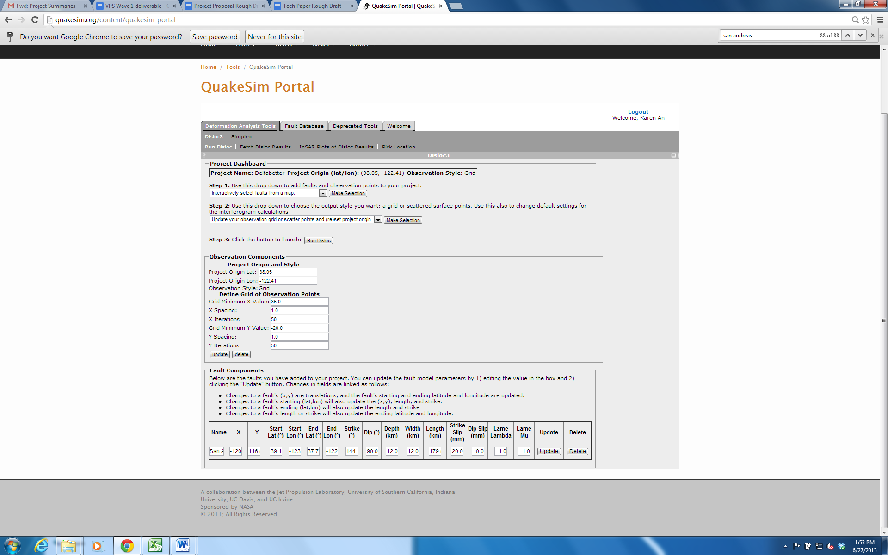

Here, you can adjust the size and fineness of the output grid. Grid Minimum X Value shifts the grid left and right. Grid Minimum Y Value shifts the grid up and down. X spacing and Y spacing determine the space between output points in the x and y directions, respectively. X iterations and Y iterations are the number of points per line in each direction. For example, a very detailed and large grid would have high Grid Minimum values, low Spacing, and high Iterations. Click the update button once you are done making adjustments.

1. 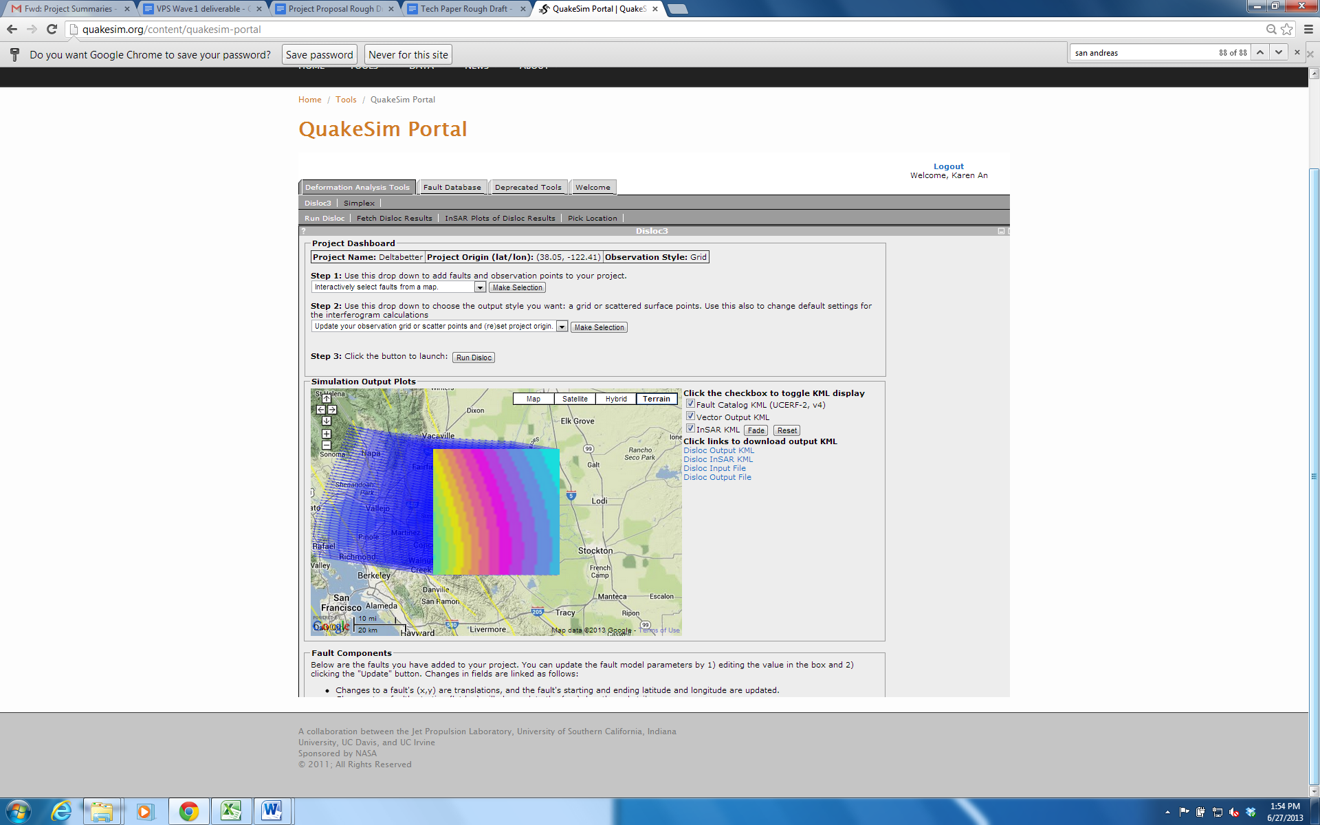It is much easier to visualize how to adjust your grid by running Disloc in between edits. To do so, click the Run Disloc button in Step 3 on the Project Dashboard. Uncheck the InSAR KML to only view the vector output.
2. 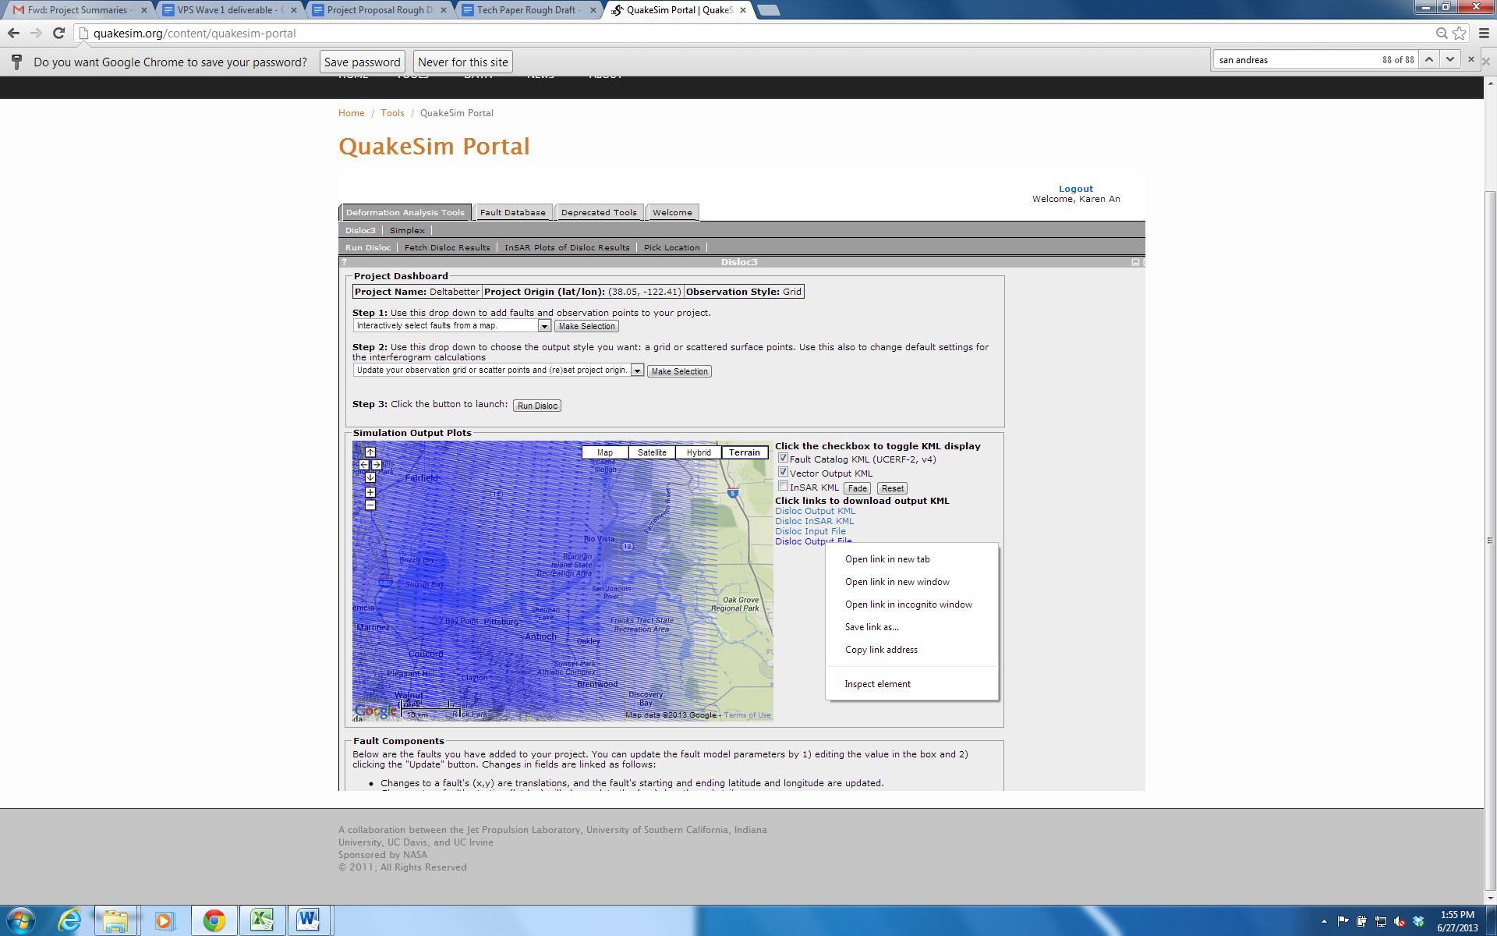Further changes can be made by repeating Step 7. If you are satisfied with the observation grid, right click Disloc Output File to save your result. Add the file ending “.txt” to your file when saving.
3. To view your output in ArcMap, we must first convert the file to a readable version. This can be done by running qsxy2tilt (a python script provided by Timothy Stough, JPL/Caltech) in the Command Prompt. Navigate to the folder containing all python files and the QuakeSim output. Run the following line of code: *qsxy2tilt.py -i quakesim.output.txt -o output.csv* where quakesim.output.txt is your QuakeSim output file and output.csv is the name of the resulting Excel table.

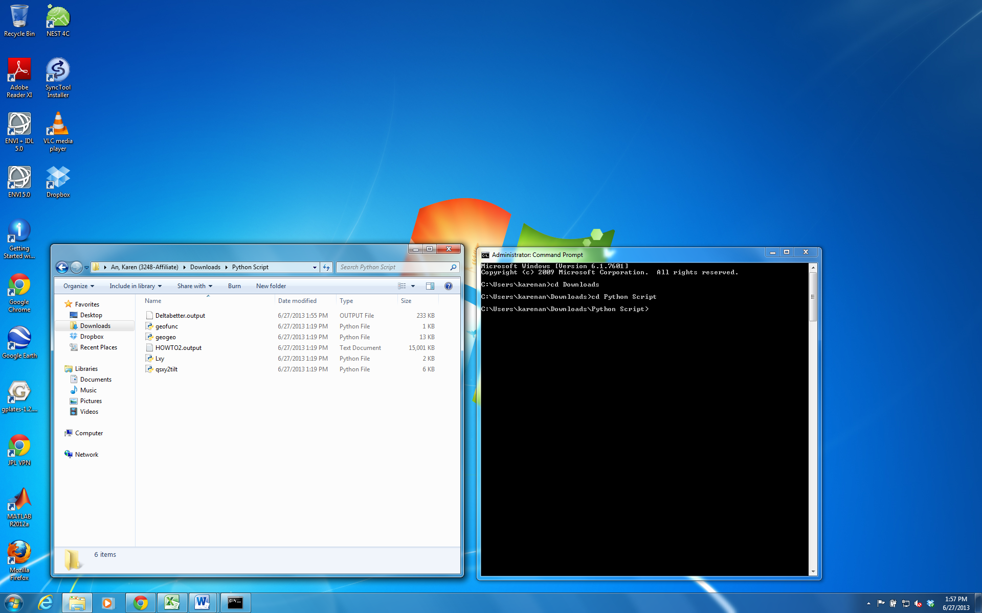

When it has finished running, you should see a csv file in the corresponding folder.

1. To display the output in ArcMap, first add the csv file by clicking the Add Data icon and navigating to the file.

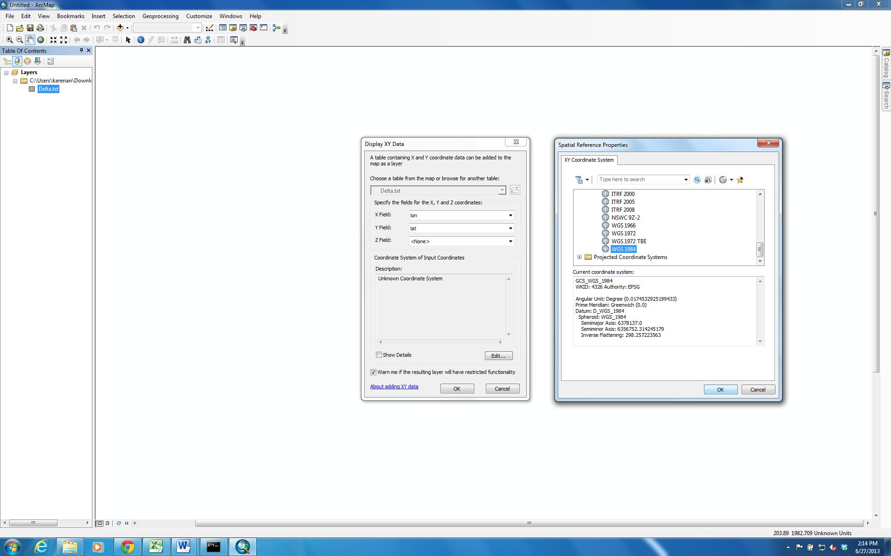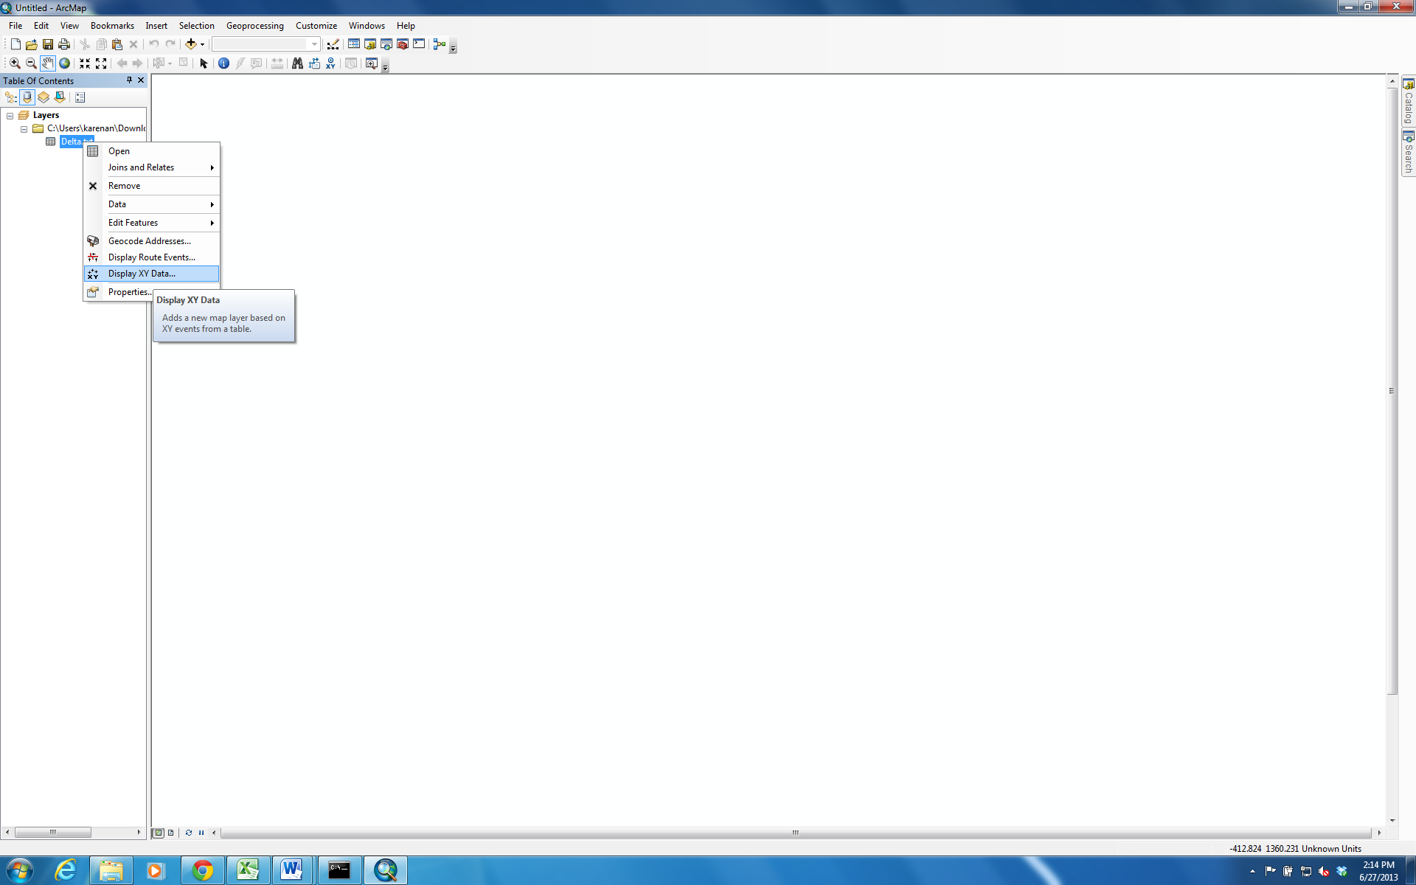

Right-click on the newly added layer, and select Display XY Data. When prompted, edit the geographic coordinate system to the desired projection.

1. The data can be exported as a shapefile (by right-clicking the layer > Data > Export Data). Some suggestions for further analysis include: adding symbology to points based on total displacement, using the Near Tool to calculate points of highest displacement closest to areas of interest, such as levee centerlines, etc.

